**Crosstab**

## Simple Cross Tab

Using the Sample-superstore let's plan to get the amount of sales for each segment in each region. We need to display this data for each year using the order dates available. To achieve this objective we follow the below steps.

* **Step -1** Drag and drop the dimension order date to the columns shelf.
* **Step-2** Drag and drop the dimensions region and segment to the rows shelf.
* **Step-3** Pull the measure Sales to the labels Shelf under Marks.

The below chart appears which shows the Cross Tab

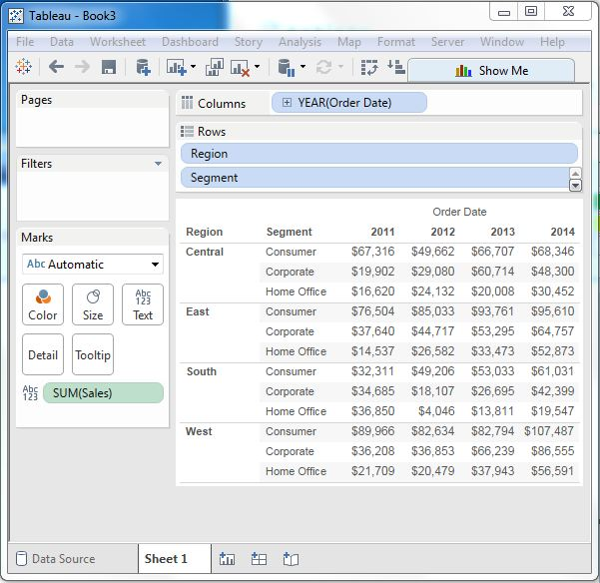

## Cross Tab - Color Encoded

We can get the values color encoded in the cross tab chart by dropping the measure field into the color shelf as shown below. This color coding shows the strength of the color depending on the value of the measure. The larger values have a darker shade than the lighter values.

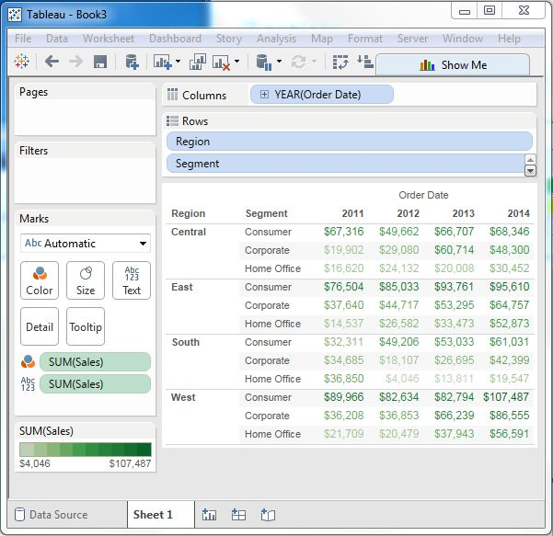

## Cross Tab with Row Percentage

In addition to the colour encoding we can also get calculations applied to the values from the measure. In the above example, we apply the calculation for finding the percentage total of sales in each row instead of only the sales figures. For this, we right click on SUM (Sales) present in the marks card and choose the option Add Table Calculation. Then we choose percent of total and summarize it as Table (Across).

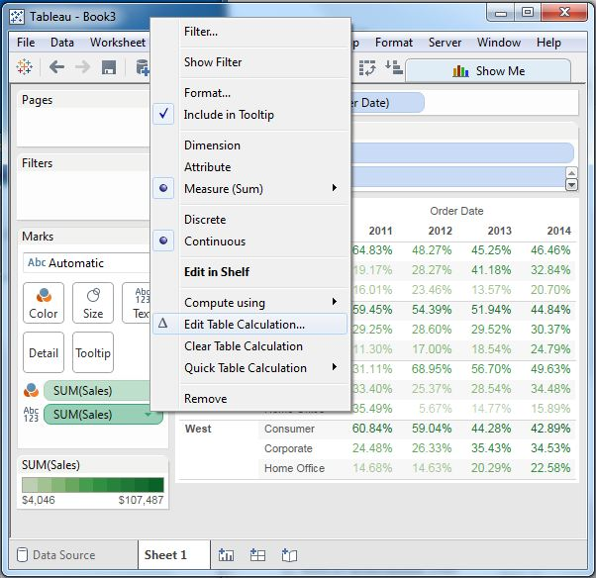On clicking OK in the screen above we find the crosstab chart created with percentage values as shown below. 